Loop in c language

It is also called iterative control instructions (iterative means repetative)

When we want to repeat some set of intruction in your program then we use loop

Their are three methods to apply loop :

1. while
2. do while
3. for

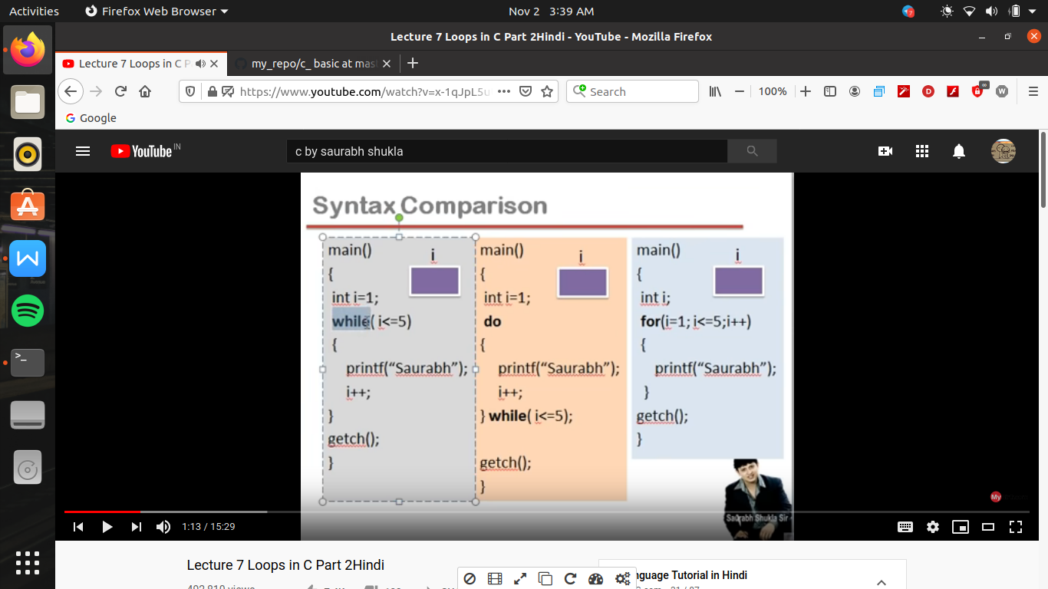

for ex-

syntax of while

while(condition)

{<this is while body what ever is intructions in give in the curly bracket(i.e while body) will repeat >

}

working of while when processor came to while then what ever be the condition is given was evaluated on the basis of true or false

and if statement is true then whatever is instruction is written in the while body will run

then after execution , then again processor go to the the while then again check the condition and if condition is true then it will again run the while body context or aisa jab tak hoga tab tak condition false nhi ho jati

so hame condition bhi bahot care se likhani hogi kyu ki agar wo condition constant rahegi toh , wo instruction never ending program ban jayega

so we can add atleast a variable in the condition

or while body me ek aisa instruction hona chahiye ki jab wo instruction ko dobara run kare toh variable ki value change ho jaye

#include<stdio.h>

int main()

{

int x=1; //counter variable ka initialization yaha se ho raha hai

while(x<=5) //here we use while

{

printf("hello \n"); //now here we want to print shashank 5 times for this either we have to write this statement 5 times or we use loop

++x; //thus x=x+1 we add this operator to increase the value of variables so that after a particular process the condition will yield false and the program will end , i.e jab dobara condition change ho tab x ki value change ho jani chahiye

}

return 0;

}

(here in this while condition is checked by 6 times , 5 bar true and ek bar false)

while loop also called as entry control loop because block ke andar jayege hi kab jab condition true hogi

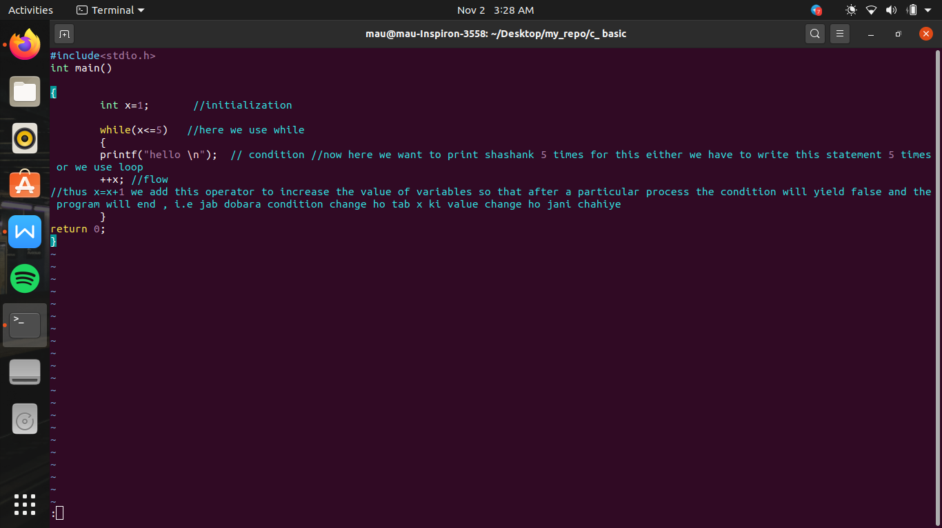

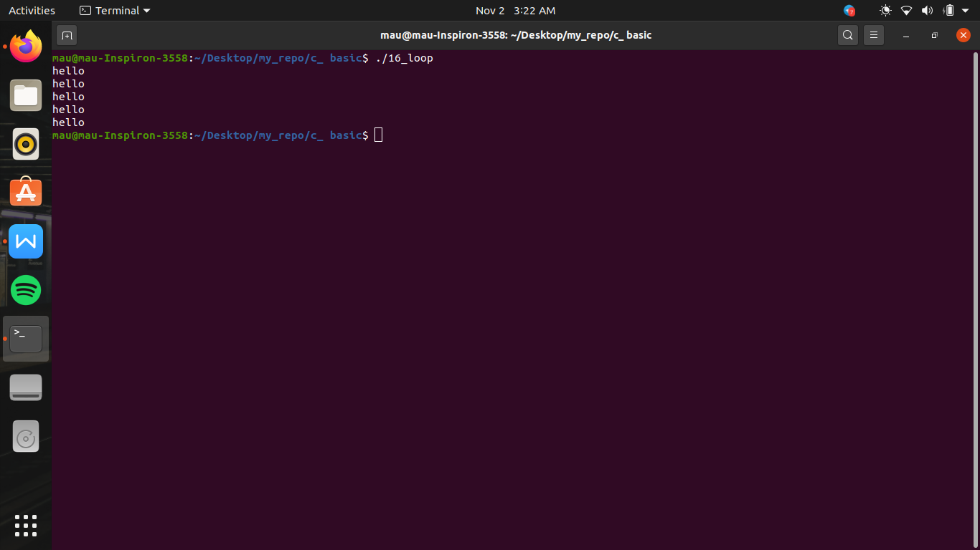

here x is a variable which control the loop thus it is also called as counter variable

dowhile ->

syntax

#include<stdio.h>

int main()

{

int x=3; //counter variable , initialise as value 1

do //by this processor directly go into the body of do and perform the intruction

{

printf("hello\n");

x++; //now after performing the instruction the value of variable is increased

}while(x<5); //here value of x become x+1 now here condition is checked if it is true then processorn then move to "do" the instruction again but if condition becomes false then the program will end

return 0;

}

(here the condition is checked by 1 less the condition checked by while loop)

here do-while loop exit control loop kahalata hai kyu ki block ke bahar a rahe hai tab condition check ho rahi hai es me agar condition starting me hi false ho toh bhi ek bar toh program kar dega

for loop ->

jayada programmer ko for loop hi pasand ata hai kyu ki operation ko control karane ke leye initialization , condition or flow yeh tino kam ek hi jagah ek sath kiye ja sakte hai

toh yeh readability ke hi sab se acha hai.

syntax

#include<stdio.h>

int main()

{

int x;

for (x=3;x<10;++x) //in for loop 2 semi colon ; lagana compulsory hota hai , jab for instruction run karega toh pahale expression 1 execute hoga i.e initialization section, fir expression 2 i.e control section, and if expression true hai toh processor block me ja kr program run kar dega of fir .

{ printf("hello \n");

} // now after perform the task of written in block then the processor will go to the third expression and run that command i.e flow condition will run the , then we again come to condition ie expression 2 yani ki exrpression 1 i.e initializing section sirf ek hi bar chalega the this loop will continue till the false condition occur return 0;

}

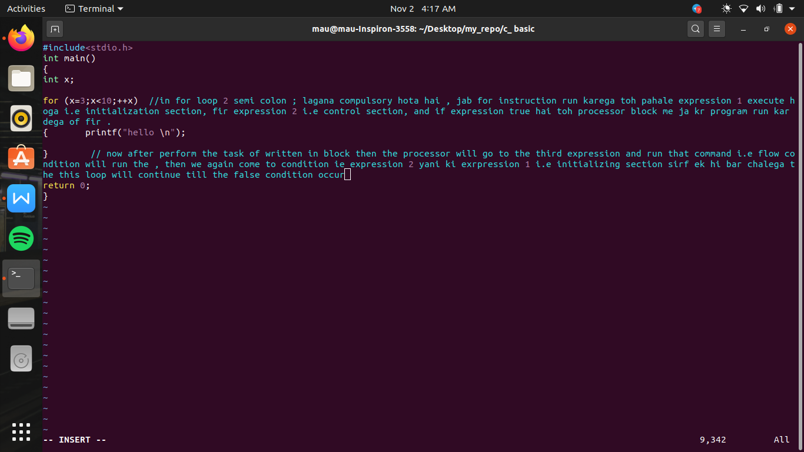

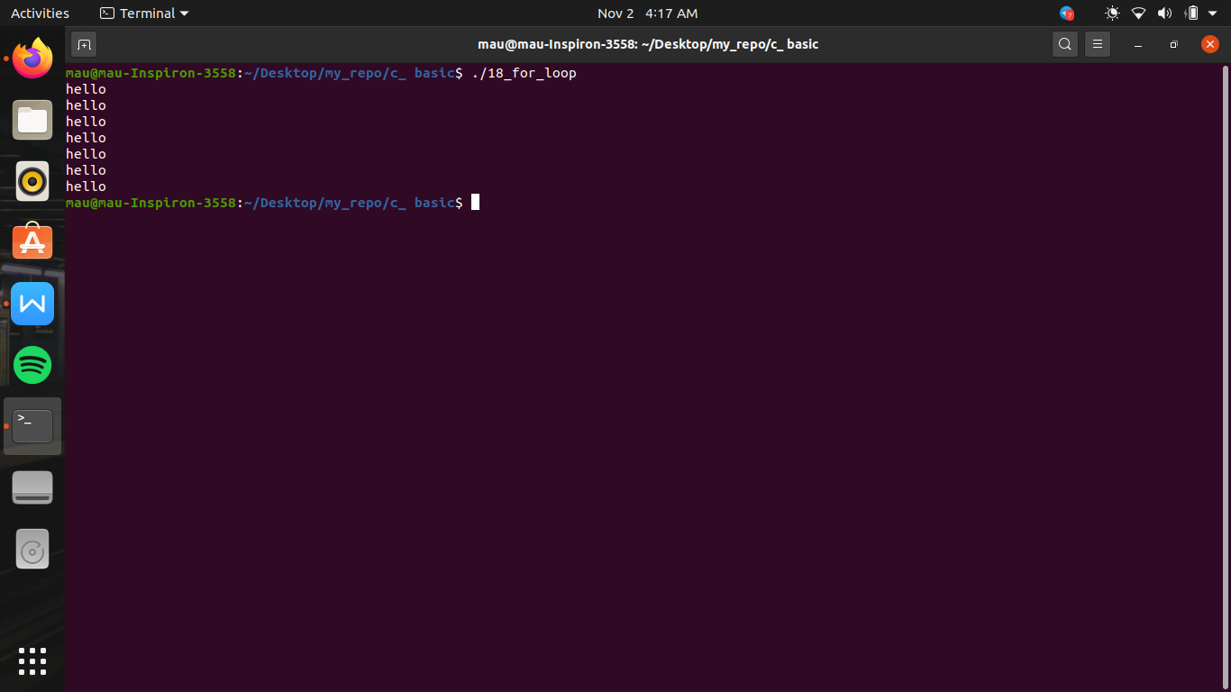

break keyword ->

break ka use can be possible only either in loop body or in switch body , inspite of it their is no other place to use it

break in loop word work as to terminate the work of loop as incomplete i.e beech me hi terminate kar deta hai

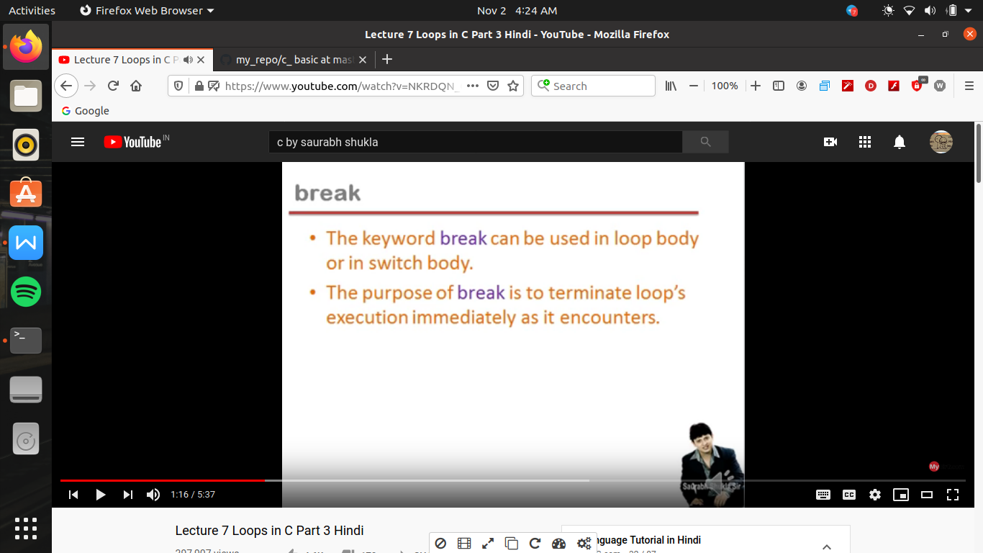

#include<stdio.h>

int main()

{

int x=1,y;

while(x<=5)

{

printf("enter a number \n");

scanf("%d",&y);

if(y<4) // break ka use waha hota hai jab hum pata toh ho kitani bar instruction run karwana hai but hum yeh bhi chahate ho kuch kuch special jagah pr loop ruk jaye

break; //if y<4 the then the program will break in between or jaise hi program break hoga processor loop ke block se turant nikal jayega or bahar wale instruction run karwa dega

x++;

}

x==6?printf("end normally \n"):printf("applied break\n"); //yani ki jab with out break apply hue program normally end hota hai toh use normally end kahate hai

}

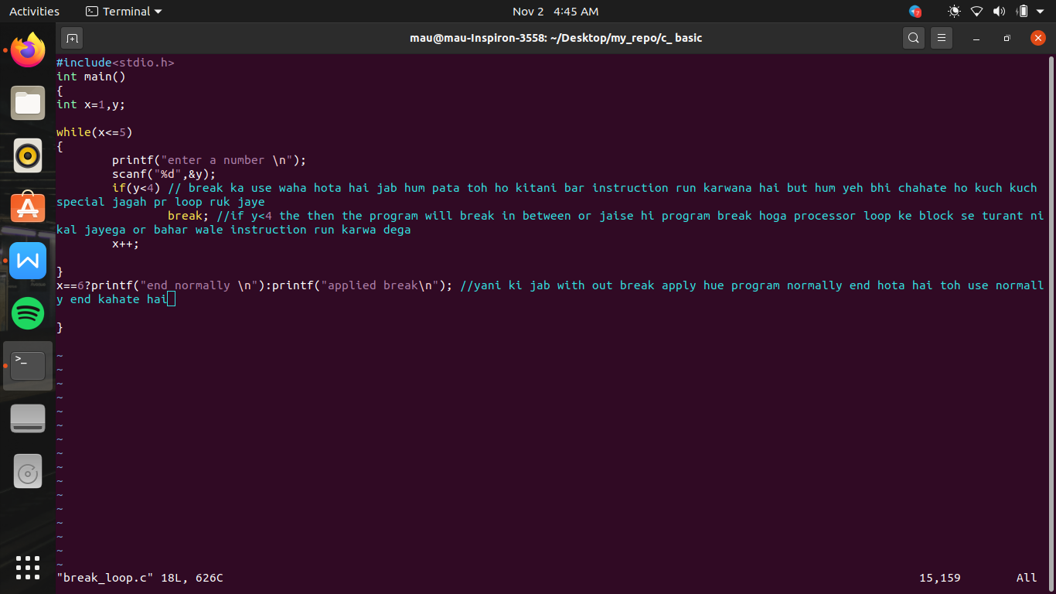

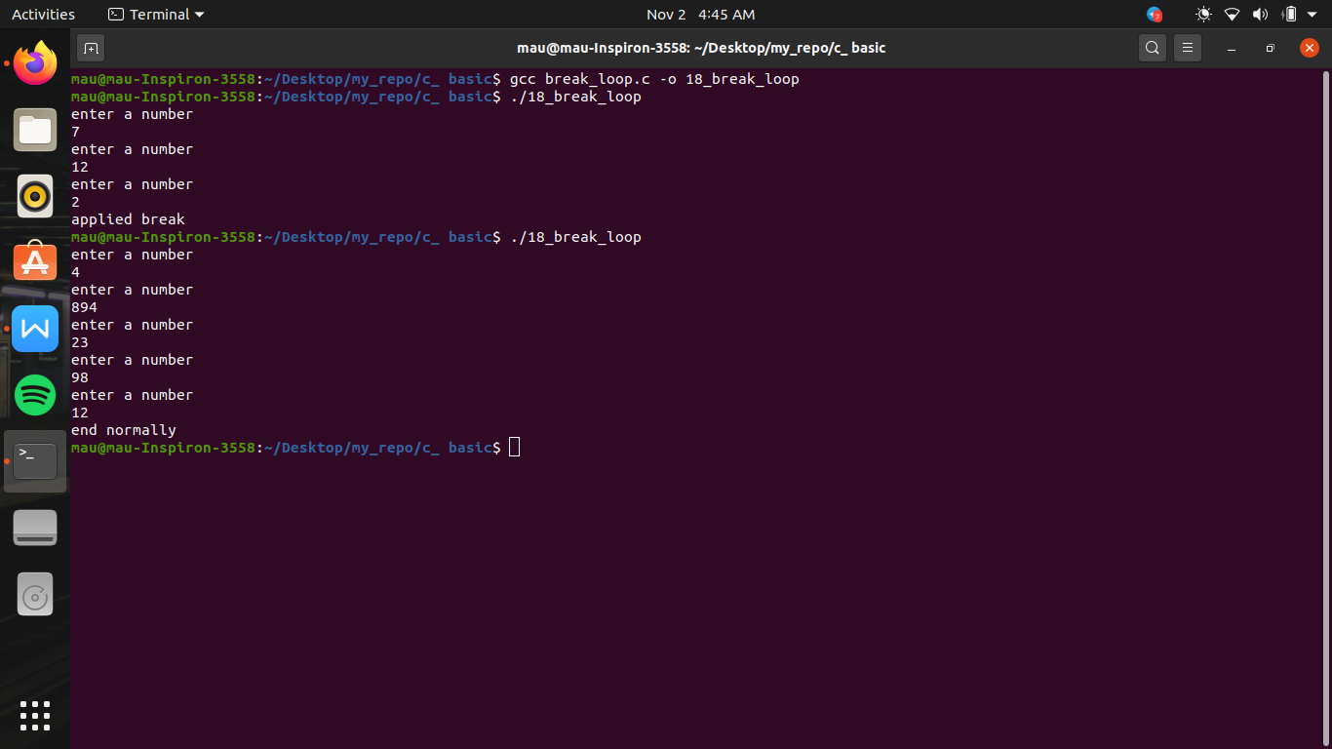

switch control ->

agar hamare pass bahot sare options ho then if-else or nasting of if-else suitable na ho toh waha switch control kam ate hai

switch control instruction ->

switch(expression)

{

case constant : code;

case constant : code;

case constant : code;

case constant : code;

default:code;

}

here we use 3 keywords switch, case, default.

in “if” expression written paranthis is called as condition and us ka evaluate true or false ke term me karate the

but in switch the expression written in the paranthis were not evaluated as true or false , balaki expression a ek result nikala jayega , calculate ho kar koe constant wale result mil jayegi

switch means , processor will jump to the location or case inside the block whose constant value of the case matches with the expression constant of switch and that code will run which is written with that case this code can be of single or also can be of multiple lines after executing that case then it will come to the next sequence case from top to bottom or agar hum chahate hai ki sirf wohi case run ho toh har case ke code ke bad we have to write break

which take the processor to out of the switch block immediately

or job koe esa expression hota hai ki wo block me likhe kisi code se match nhi karata toh wo default ke pass ata hai or default ka code run kar deta hai

and after that control will come out of of switch block (as because it is not like a loop)only run one time

rule ->

1. har ek case me jo constant likha hai wo unique hona chahiye yani same nhi hona chahiye
2. this real value can be integer constant or a character constant but cannot be a real value
3. yeh zaruri nhi hai case me likhe constant sequence me ho

